#StopAsianHate: Investigating and Comparing Conservative New Media Outlet Fox News’ Portrayal of Mass Shootings Through a Racial Lens

Case Study
Simon Fraser University
CMNS 452: Race and the Media
Emily Sweeney

Introduction
There have been significant increases in anti-Asian violence in the past year, including the March 16, 2021 massage parlour shootings in which eight people were killed, six of which were Asian women. This violence follows a litany of other anti-Asian crimes, assaults, and murders, which has culminated in the creation of the hashtag/movement #StopAsianHate. These sentiments have likely been perpetuated by COVID-19, a virus that is believed to have originated in China, which spread across the world, resulting in a global pandemic and cultural shutdown. Based on the virus’s country of origin, Asian-Americans are facing increasing discrimination and race-based trauma (Litam, 2020).
At the core of this hate crime is an intersection of race and gender, as the majority of victims were Asian-American women and possibly sex workers. As seen from previous academia, Asian women face a phenomenon called Ornamentalism (Cheng, 2018), in which these women are seen as an ornament, an empty object to look at and in some cases, as with the character Kyoko in Ex Machina, as a servant used for sexual gratification and ornamentation. We also see this phenomenon in the technology of the “smart wife” or voice assistant industry, with young, female, Asian voice assistants/devices which perpetuate female oppression and the belief that women should be subservient, which many men (and some women) sexualize (Kennedy & Strengers, 2020). These depictions are important because what is produced in the media is often reproduced in society. The image of the subservient, quiet, sexually ornamental Asian woman may work in correlation with these racist sentiments and result in hate-crimes.
Alongside this representation is the image of the white man as ideal, good, clean, and pure (Dyer, 1997). White supremacy has a strong hold on western culture, and in this case, likely resulted in the ornamentation of these women, and the awful acts the shooter committed (Cheng, 2018). The white man is often depicted as the hero, or at the least, the poor downtrodden man (Dyer, 1997). The way that the media represents white men is important, especially in cases like the Atlanta shootings where the perpetrator committed a likely racially motivated hate crime.
Case Study
My intent for this case study is to explore the media coverage of the March 16, 2021 massage parlour shootings, which were suspected to be racially and gender-motivated, inspect what news sources and their audiences have to say on the issue, and review police statements. The main focus of my research is how Fox News covered the issue in comparison to their coverage of similar shootings committed by a suspect of a minority race, and how Fox News covers the issue compared to CNN.
Methods
In this study, I plan to analyze articles from Fox News and CNN regarding the recent shootings at two massage parlours in Atlanta that took place on March 16, 2021. I will be looking at the responding tweets and comments branching from these posts, to explore the general opinion of the situation and what each specific community believes. Additionally, I will be looking at similar stories from Fox News where other races were highlighted, to analyze if the publication’s writing and tone were reproduced or fluctuated.
For my text selection, I chose full written articles, not articles for videos or live updates. I chose comments that were representative of the general tone of the audience and had the most likes.
Sample Research Questions:
Hypothesis 1: Among its articles on domestic terrorists, Fox News will be more sympathetic to Caucasian suspects than suspects of other races.
Hypothesis 2: The tone of coverage on Fox News will be more dismissive of the deaths of these women than the tone of coverage on CNN.
Hypothesis 3: Fox News will be more sympathetic to the perpetrator than CNN.
Hypothesis 4: Supporters of Fox News will be more sympathetic to the perpetrator than supporters of CNN.
I will additionally investigate the issue using Du Gay’s 1997 cultural studies model. There are multiple nodes in the circuit of culture diagram that this study could connect to.
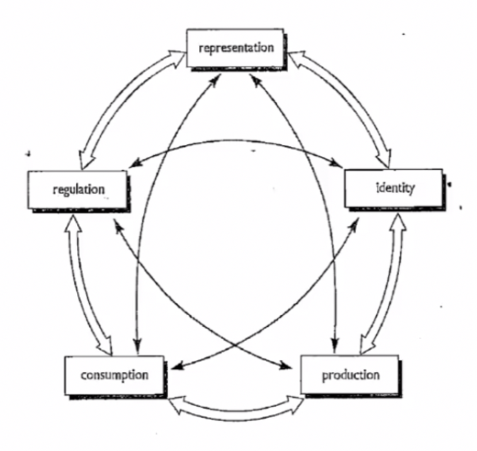
Figure 1: Circuit of Culture Diagram (Du Gay, 1997)
The first potential node is representation: How have these women been represented? How has the perpetrator been represented? – These women have been represented as victims, but also Asian sex workers to many people, despite these claims being unsubstantiated. In terms of the perpetrator, I believe the majority of people see him as a white-supremacist criminal, but, opposingly, we see depictions of him as a nice, young, church-going man that got led down the wrong path, as represented in some of the articles I will be exploring.
The second potential node is Identity: What social identities are associated with the issue? First is the social identity of Asian women as machines for servitude and pleasure (Cheng, 2018). Additionally, we see white men as being supreme and dominant, representing the ideal, as well as cleanliness, goodness, and purity (Dyer, 1997).
Academic Research
In their 2020 article on the emergence of sinophobic online behaviour related to COVID-19, Tahmasbi et al. (2020) conducted a study in which they collected two large-scale datasets from Twitter and 4chan over the duration of five months and analyzed them to determine if there was a rise in sinophobic sentiments. The study found that there was a significant rise in Sinophobia online related to COVID-19 and that many believe China to be responsible for the pandemic, while others have created new sinophobic slurs to slew.
Dubey (2020) performed a similar analysis in their study in which they took 16,000 tweets from April 11-16, 2020 and analyzed their associated sentiments/emotions. This analysis searched for terms like “Chinese Virus” “Wuhan Virus” and “Chinese CoronaVirus”. The study found that the majority of these tweets were of negative sentiment and were crafted by quite sad, angry, and disgruntled writers.
Mills (2017) wrote a critical discourse analysis of the Fox News Channel’s segments from August 2014 to March 2015. The study found that Fox News is perpetuating racist stereotypes and discourses, which obstruct the addressing of racism in the United States. This is very similar to the model of this current study.
A study by Darling-Hammond et al. (2020) found in their own analysis of social media that conservatives, and conservative media specifically, were displaying a perception that Asian Americans were less American and instead considered a “perpetual foreigner”, while framing COVID-19 as a “Chinese” virus. This is important because this study, along with some media examples, shows that these conservative/republican news sources may have a positive correlation to anti-Asian sentiments and crimes, as well as white supremacy, the basis of my query.
As Coe et al. (2008) found in their article, the news cycle has become more and more divided, and the perspectives each side publishes are more extreme. This article focuses on cable news but is likely representative of the greater news cycle. North America faces a red versus blue conflict, with both parties willing to opinion monger, and move further and further from objectivity (Coe et al., 2008). Members of one political party will be critical and skeptical of the others’ sources, and this creates an echo chamber in which members of each political side only engage with news from their side of the spectrum, and their views are not challenged (Coe et al., 2008). This is dangerous because no side is right all of the time, and this conflict can result in extremist views and dangerous, incentivized audiences.
Findings
Suspects of Different Races
If we compare the representations of shooters of different races on Fox News, we can see significant variations in wording and tone concerning these criminals and mass shootings.
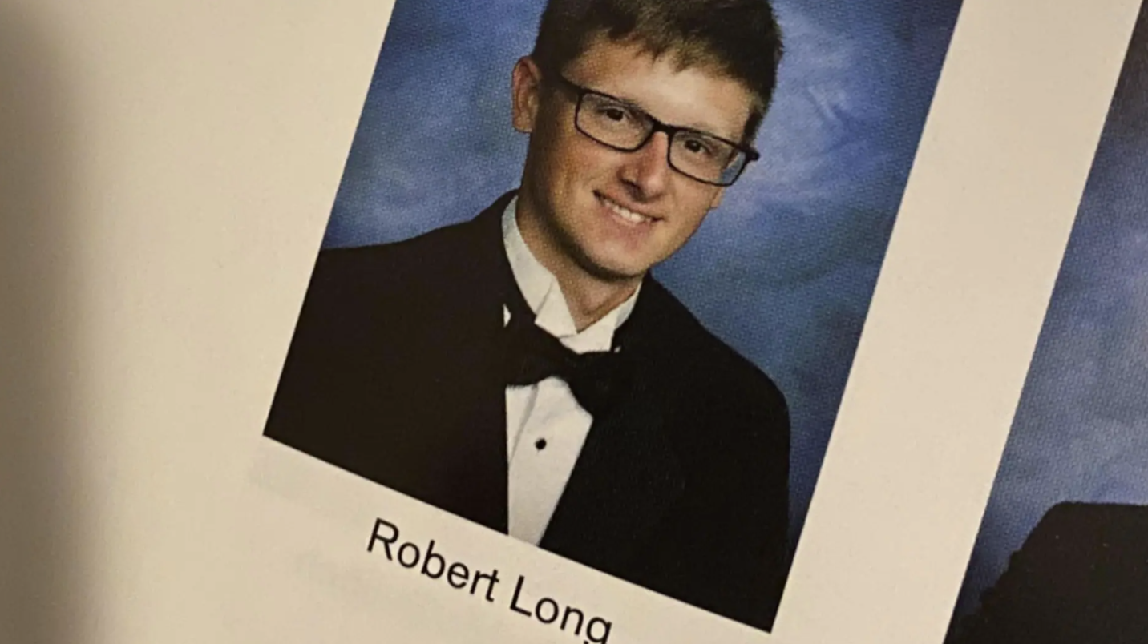
Figure 1: Atlanta shooting suspect Robert Long
Fox News released a full article on the shooting suspect’s life which included pictures of him from high school looking very young and clean, and his former high school classmates expressing shock at the shootings (Conklin, 2021). The suspect’s classmates call him smart, quiet, calm, and collected, as well as caring and religious (Conklin, 2021).
The article includes excerpts from an interview with the Cherokee County Sheriff, Frank Reynolds, in which he states that the suspect may have a “sexual addiction” but also that it was too early in the case to confirm if they were dealing with a hate crime (Conklin, 2021, para. 3). The article additionally includes statements from the Cherokee County Sheriff’s Office Captain, Jay Baker, in which he said the suspect described having a “sexual addiction” and the massage parlors may have been “a temptation he wanted to eliminate” (Conklin, 2021, para. 4). Baker also describes the suspect as allegedly taking responsibility for the shooting (Conklin, 2021).
The article included the following quote from one of the suspect’s female former classmates.
“I really didn’t know him that well but I would’ve never expected this," she said. "We came from a pretty good town, and everyone seemed to know who he was or at least his name, but he was never super social. I hate to give him the benefit of the doubt because what he did cannot be justified but I just feel like there [has got to] be a reason for what he did.” (Conklin, 2021, para. 15).

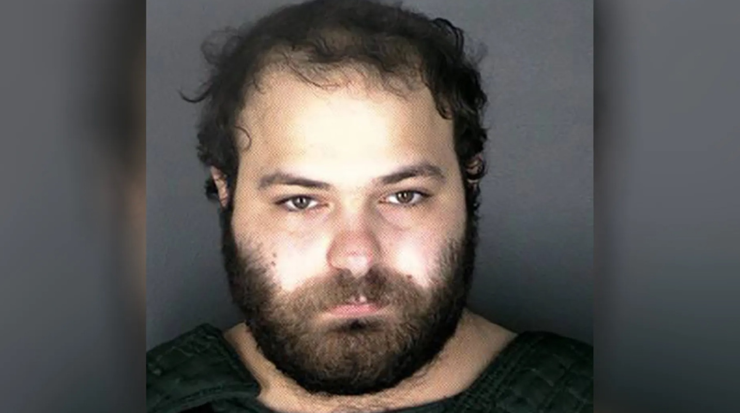
Figure 2: Boulder shooting suspect Ahmad Al Aliwi Alissa
Fox News published an article on the March 22, 2021 Boulder, Colorado shooting suspect, which included a significantly different representation than what we saw with the March 17, 2021 Atlanta shooting suspect.
The article used the suspect’s mugshot as the lead photo, alongside statements from former high school classmates that describe the suspect as short tempered and paranoid, (Pagones, 2021c, para. 2)
Another classmate described the suspect as “scary to be around” and said that the suspect had once threatened an opponent during a wrestling match (Pagones, 2021c, para.10).
“"His senior year, during the wrestle-offs to see who makes varsity, he actually lost his match and quit the team and yelled out in the wrestling room that he was like going to kill everybody," said Marvel, who reportedly graduated in Arvada West High School’s Class of 2018. "Nobody believed him. We were just all kind of freaked out by it, but nobody did anything about it." Marvel also told the Post how Alissa "would talk about him being Muslim and how if anybody tried anything, he would file a hate crime and say they were making it up."” (Pagones, 2021c, para. 11-12).
The suspect may present as a White male, as one of the people who called in the shooting reported, but clearly identifies as a Muslim man with a non-European name and was likely represented differently for it.
The most significant visible difference in these two suspects is their race. Both suspects were 21-year-old males, who have spent the majority, if not all, of their lives in America. Both suspects went on killing sprees, only days apart, yet, they were portrayed very differently by Fox News.
This could be connected to Dyer’s 1997 article on whiteness. In western culture, people with lighter skin are seen as good, clean, and pure, while people with darker skin are seen as bad, or evil, or lower class (Dyer, 1997). This could be why we see a more severe depiction of the Colorodo suspect’s character as bad and evil, and why the Atlanta suspect is described as being driven by a sex addiction presented alongside an article about how shocking it is that he would commit these acts (Pagones, 2021a; Conklin, 2021).
Victim Representation
In addition to the difference in representation for the suspects, there was also a difference in representation for the victims of these shootings. Fox News rarely named the victims of the Atlanta shootings, with only three out of twelve articles featuring some of the victim’s names briefly (featured: Pagones, 2021a; Day, 2021; Associated Press, 2021a) (not featured: Associated Press, 2021b; Casiano, 2021a; Carlson, 2021; Cawthorne, 2021; Conklin, 2021; Flood, 2021a; Flood, 2021b; Kurtz, 2021; Sorace, 2021a)
Fox News has written no full articles about any of the victims, except for articles reporting on the money that several of the victims’ families were given from fundraisers and celebrities after the shootings (Day, 2021; Associated Press, 2021a). Even in those articles, only five of the eight victims were named (Day, 2021; Associated Press, 2021a). The victims were also never pictured, in any of the articles, compared to the many shots of the suspect included in these articles.
While in reporting the Boulder, Colorado shootings, there were no explicit articles representing each of the victims, the one police casualty had a dedicated article, and many pictures of him were included throughout. Additionally, in contrast to the Atlanta shootings, the victims were explicitly named and featured in seven out of eleven articles written on the shootings by Fox News (featured: Aitken, 2021; Best, 2021a; Best, 2021b; Pagones, 2021b; Pagones, 2021c; Sorace, 2021a; Sorace, 2021b) (not featured: Gaydos, 2021; DeMarche, 2021a; DeMarche, 2021b; Casiano et al., 2021b)
There were a number of differences in the identities of the victims that could be connected to these dissimilarities in representation. The victims of the Atlanta shootings were primarily Asian, and suspected sex workers, in comparison to the primarily Caucasian, randomly targeted victims of the Boulder, Colorado shootings, who were attacked at the grocery store (Pagones, 2021a; Sorace, 2021a; Best, 2021a).
This issue could be connected to ornamentalism (Cheng, 2018). The victims of the Atlanta shootings were primarily Asian, female, suspected sex workers, and likely as a result their importance was downplayed and the victims made into numbers and statistics, rather than people (Cheng, 2018). The only articles that fully feature victims focus on the money their families received after their deaths, which seems to present the issue as a transaction rather than a tragedy, as though these women were made to be sold or purchased, which speaks to the theory of ornamentation (Cheng, 2018). In Atlanta, the events were described as a series of shootings, attacks, and killings (Casiano, 2021a; Associated Press, 2021a; Kurtz, 2021), while in Colorado, they were considered a “massacre” (Demarche, 2021a) and “rampage” (Best, 2021a). This is considerably more severe language, which supports the idea that these attacks were considered worse or more heinous, despite their similarities. By pushing these victims into the background and making them into ornaments as Cheng (2018) describes, made for adornment and sexual gratification, Fox News empowers white supremacy and the oppression of Asian women. This representation espouses that Asian women, particulary sex workers, are not important, and that their lives are not that meaningful, in comparison to a group of Caucasian victims.
CNN Coverage
In comparison to Fox News, CNN places a much stronger emphasis on the importance of the victims of the Atlanta shootings, and were less sympathetic to the suspect.
CNN reported the suspects “sex addiction” but added that Atlantans were skeptical of this reasoning, as the suspect didn’t target any of the proximate sex-related businesses, such as strip clubs (Chen et al., 2021). There is also a strong connection to ornamentalism with this idea, because these victims could have been targeted due to the fetishization of Asian Women in particular (Cheng, 2018).
CNN additionally published an article on the suspect, though it was less personal and seemingly sympathetic (McLaughlin et al., 2021).
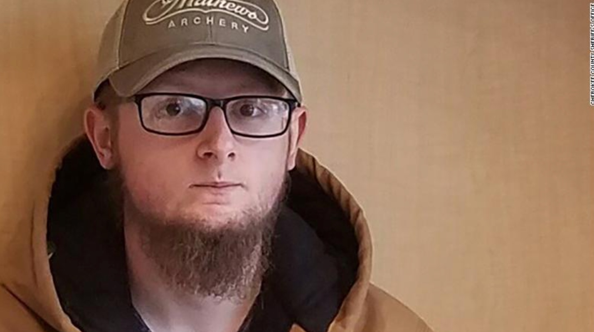
Figure 3: Robert Aaron Long, the suspect in Atlanta spa shootings

The article provided a more recent photo and investigated further into the suspects’ sexual addiction and frequent pornography viewing, as well as the treatment/rehabilitation he received to help with his sexual addiction. The suspect’s former roommate from the rehab facility he attended detailed the suspect’s issues with sex and religion, as well as the many relapses the suspect experienced when he would go to these massage parlors. The article further described how the suspect purchased the gun he used to commit these acts. It is possible Fox News avoided including this information to avoid supporting gun control, and intense background checks to purchase a gun, which many Republicans are stringently against (Kantack & Paschall, 2020).
Additionally, CNN published an article dedicated to the lives and memories of the victims of the Atlanta shootings (Holcome & Andone 2021). Each victim is featured, pictured, and remembered in turn. In comparison to the coverage from Fox News, these victims were seemingly much more respected by CNN. By naming all of these victims and presenting them as more than sex workers and massage parlor clients, CNN diverted from ornamentalism, and portrayed the complexities of these peoples’ lives (Cheng, 2018).
Public Response: Fox News & CNN
Through reviewing the response of the public to articles on the shootings from Fox News and CNN, there are a number of notable observations. First, while Fox News allows comments on their articles, CNN does not. However, CNN publishes their stories on Twitter as well, allowing comments and some general sentiments to be gathered there. Comments were chosen based on their accuracy of general sentiment and high number of likes.
Provided are five of the most liked comments from the Fox News article Atlanta shooting suspect Robert Long: What to know (Conklin, 2021).
Many of the comments discussed the atrocity of these acts, however, some of the comments with the highest number of likes were sympathetic to the suspect and his mental health, and his struggle with religion.
This comment by Who’stosay discusses the issue and proposes that the suspect be given the death penalty. This is a very contentious view, and the subject of the death penalty has become very politicized.
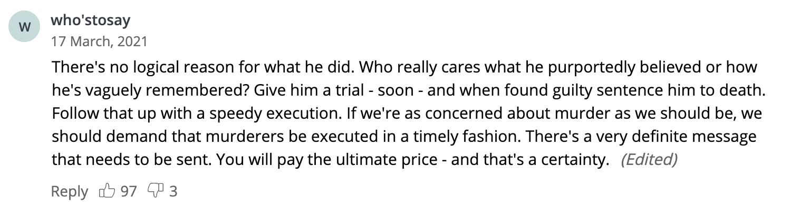
Figure 4: Comment from Whos’tosay on the subject.
Many comments, such as this one by Denkellyl, brought up gun control, and why this case does not support stricter gun control.
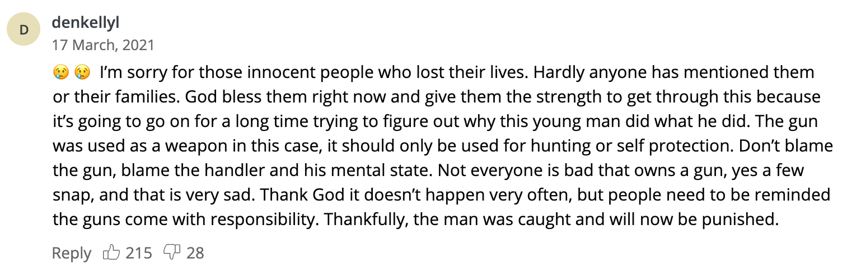
Figure 5: Comment from Denkellyl on the subject.
There were a multitude of comments about the suspect’s mental health and connection with god and religion, such as these comments from OldLadywithcommonsense, Crust_Is_Risen, and HugoTusa.

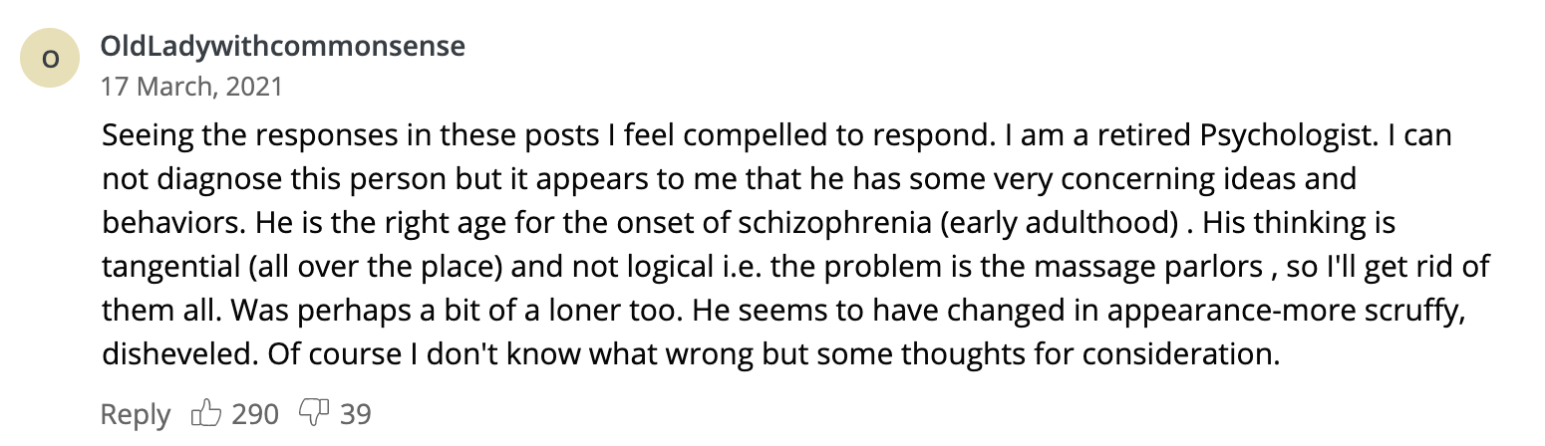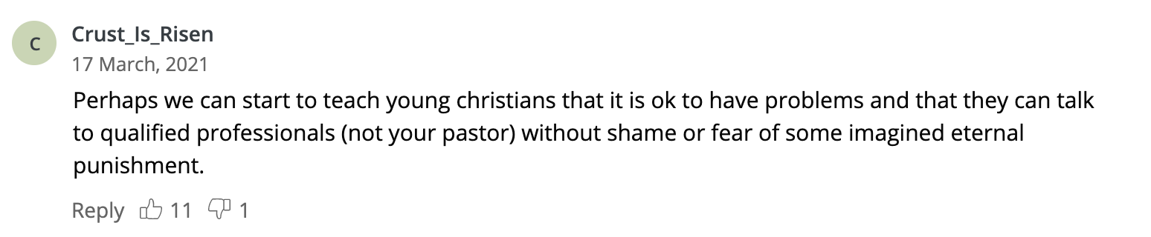
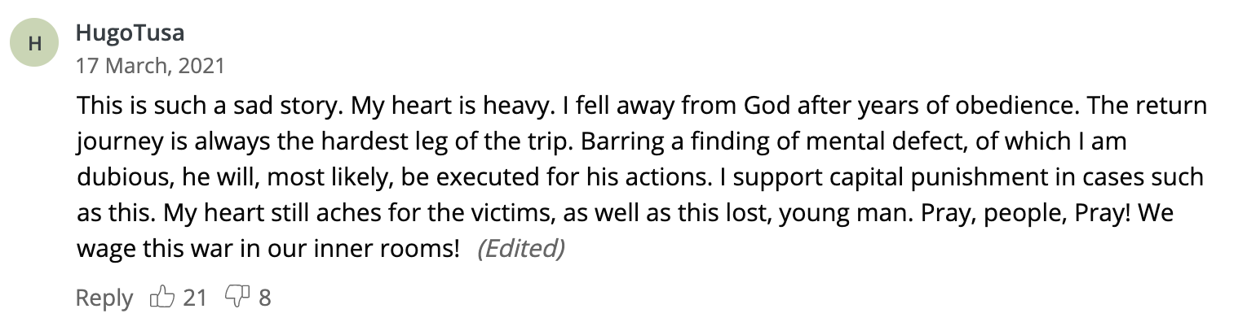
Figure 6: Comments from OldLadywithcommonsense, Crust_Is_Risen, and HugoTusa on the subject.
Alternatively, the comments on CNN articles on Twitter were very critical of the suspect and his unwillingness to admit his specific targeting of Asian women (CNN, 2021a). Zarychta (2021) commented on the commonalities of the victims, and the rise of racial violence against Asian people.
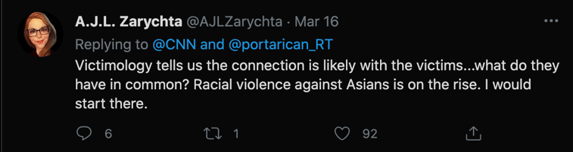
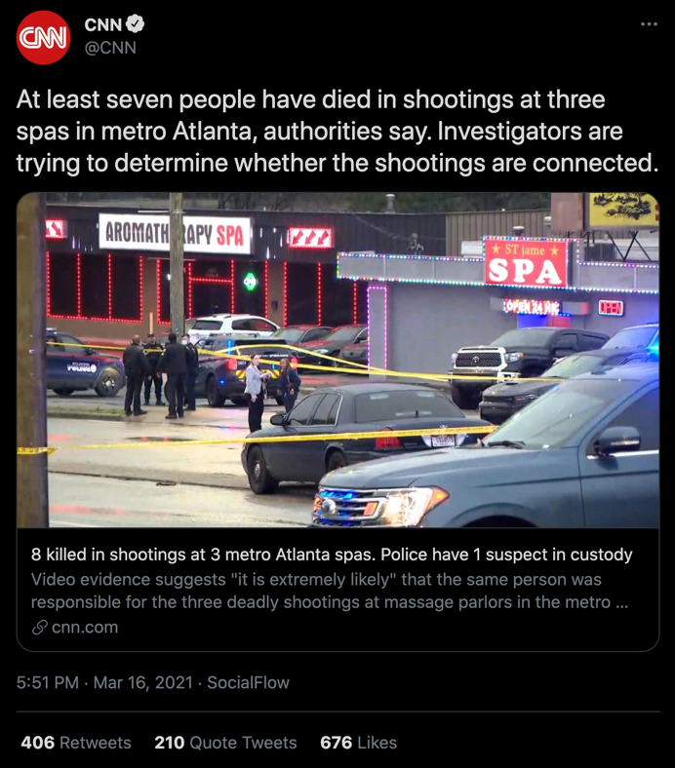
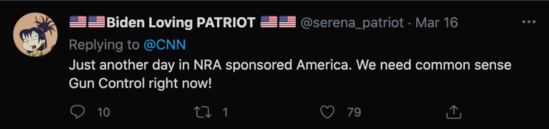

Figure 8: CNN Tweet on the shootings, with comments from @AJLZarychta and @serena_patriot
Biden Loving Patriot (2021) also discusses gun control, in opposition to what many in the comments of the Fox News article were saying. This is another common theme that can be found in the comments of these tweets/articles from CNN, as you may be able to tell from the amount of likes on the comment.
In another tweet’s comments, we can see the same themes of racial targeting and racism. These tweets are very representative of the types of comments that people left.
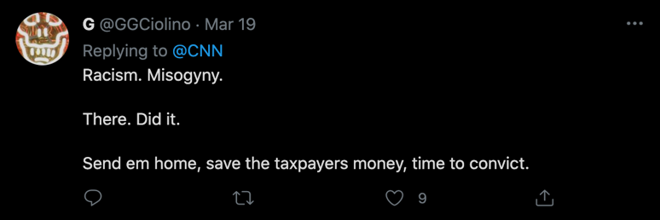
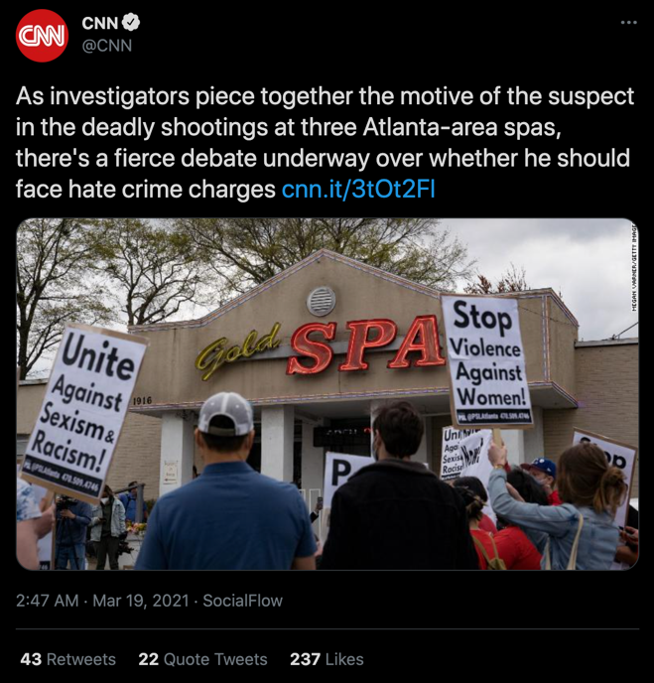
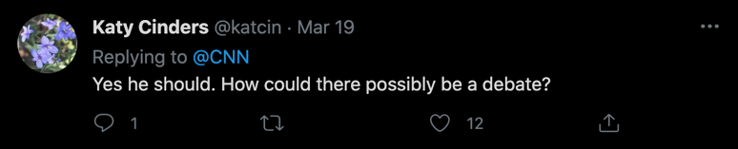

Figure 9: Figure 7: CNN Twitter Coverage of the Atlanta Shootings, with comments from @GGCiolino and @katcin
These events were vigorously covered in the media cycle, and the world was in an uproar at the implications of the Atlanta shootings. Even if certain people will dispute that the crime was racially motivated, six out of sight victims were Asian Women (Cawthorne, 2021). As a result, we saw the creation of the hashtag #StopAsianHate. Thousands of people tweeted and posted with the hashtag. Many notable celebrities tweeted out in support and denounced the shootings and the anti-Asian crimes that have been taking place throughout the pandemic.
These celebrities include actor Daniel Dae Kim, actress Mindy Kaling, and Congress member Ted Liu.
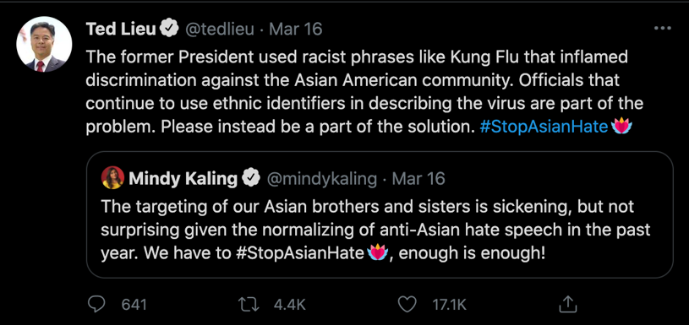
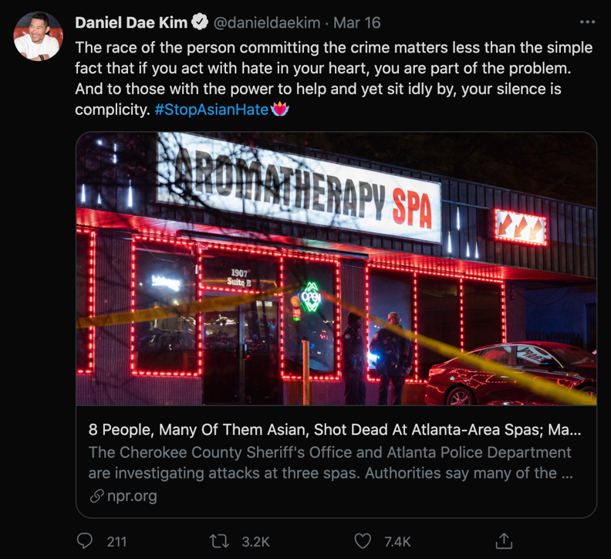
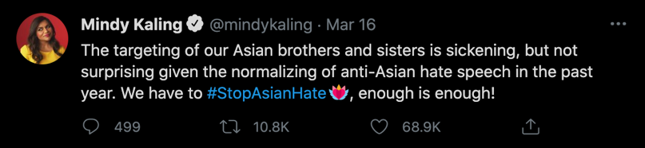

Figure 10: Tweets on #StopAsianHate from @danieldaekim, @mindykaling, and @tedlieu
Limitations
I am exploring this issue from the position of a White Woman, so I may never understand what these victims and Asian women face in general, and my own understanding of these issues may be less extensive. As a politically left leaning woman, I likely carry biases of my own that may colour the opinions included in this paper. In order to counter this bias I have reviewed word choice and the objective facts of the coverage.
Fox News and CNN represent opposite ends of the political spectrum, and as a result, may hold extreme views that most news sources do not share. However, it is important to explore these views, because Fox News and CNN are massively powerful and influential in North America.
Researching the opinions of the audiences of Fox News and CNN proved to be difficult as CNN does not have a dedicated comment section, and Fox News does not tweet out all of their articles. The solution was to use comments from Twitter for the CNN articles and comments from the Fox News site for Fox News. These are two different mediums, and as a result, may have unique audiences and not provide completely equal coverage. However, it was viable that in both cases one could gain a sense of the general opinion from the audience.
Additionally, this study was not completely representative of the beliefs of Fox News or CNN. This was a very small sample of articles and comments, so these conclusions are not exhaustive. However, as a case study, one can see how these news organizations covered this singular event, and if that is indicative of any biases.
Future Directions
The biases of media organisations, such as Fox News, have huge implications on society (Yglesias, 2018). If there are biases in these sources, they must be made clear. There needs to be further studies into Fox News and the effect it has on American politics and the American public, as well as other media organizations. As the line between objectivity and bias continues to be blurred, researchers are required to find ways to understand these issues and address them, and the impact they will likely have on viewers (Coe et al. 2008). This study is just one small example of coverage. Some will claim that anything Fox News releases is fake news, however they publish countless articles, and their power is far reaching (Yglesias, 2018).
Conclusion
In conclusion, I believe this study has found some valuable correlations between race and the media and connects to some underexplored intersectionalities. The study has looked at the difference in coverage that mass shooting suspects and victims of different races receive. The coverage of news comparing Fox News and CNN was explored. Finally, the responses of the audiences of each news organization were critically analyzed.
Having explored these different cultural texts, I believe there may be a correlation between ornamentalism, whiteness, white supremacy, and Fox News. Fox News provides a strong example for each of these theories, and from what these texts have shown, is a biased news source. In terms of Du Gay’s (1997) model for cultural studies, I believe this case study has demonstrated the different representations and identities Fox News and CNN, to an extent, produce.
I strongly believe that we must hold news agencies and the general public accountable for their racial biases so that events such as these shootings are properly investigated, and justice is served. If we do not demand justice, we will not receive it.

References
Aitken, P. (2021, March 26). Boulder shooting suspect expected to face more attempted murder charges; FBI, police to conduct 'deep dive'. Fox News. https://www.foxnews.com/us/boulder-shooting-suspect-attempted-murder-fbi-background.
Associated Press (A) (2021, March 18). Asian Americans grieve, organize in wake of Atlanta attacks. Fox News. https://www.foxnews.com/us/asian-americans-grieve-atlanta-attacks.
Associated Press (B) (2021, March 22). Atlanta shooting victims' families receive outpouring of donations. Fox News. https://www.foxnews.com/us/atlanta-shooting-victims-families-donations.
Best, P. (A) (2021, April 22). Boulder shooting suspect facing 43 more charges in King Soopers rampage. Fox News. https://www.foxnews.com/us/boulder-da-more-charges-king-soopers-shooter.
Best, P. (B) (2021, March 29). Boulder shooter was allegedly 'chuckling' to himself as he murdered ten people: report. Fox News. https://www.foxnews.com/us/boulder-shooter-was-allegedly-chuckling-to-himself-as-he-murdered-ten-people-report.
Biden Loving Patriot [@serena_patriot]. (2021, March 16) Just another day in NRA sponsored America. We need common sense Gun Control right now! [Tweet]. Twitter. https://twitter.com/serena_patriot/status/1371988934465626112
Casiano, L. (A) (2021, March 17). Atlanta massage parlors shooting suspect charged with murder; 911 audio released. Fox News. https://www.foxnews.com/us/atlanta-massage-parlor-shooting-murder-911.
Casiano, L., DeMarche, E. & Pagones, S. (B) (2021, March 23). Boulder grocery massacre leaves 10 dead including cop, suspect in custody. Fox News. https://www.foxnews.com/us/active-shooter-reported-at-colorado-shopping-center-police.
Carlson, T. (2021, March 19). Tucker Carlson: Media ignoring facts about Atlanta shooter to boost their political agenda. Fox News. https://www.foxnews.com/opinion/tucker-carlson-atlanta-shooter-media-political-agenda.
Cawthorne, C. (2021, March 17). Democrats rush to blame 'White supremacy' for Atlanta shootings, but police point to sex addiction. Fox News. https://www.foxnews.com/politics/atlanta-shooting-white-supremacy-robert-aaron-long-sex-addiction.
Chen, N., Silverman, H., & Yan, H. (2021, March 23). Asian Americans demand change after shootings: 'I want people to finally hear us ... not only when we're trending'. CNN. https://www.cnn.com/2021/03/22/us/metro-atlanta-shootings-monday/index.html.
Cheng, Anna. 2018. Ornamentalism. “Introduction” pp. 1-25 AND “Chapter 5: Dolls.” pp. 127-151. Access chapter PDFs on Canvas.
Cinders, K. [@katcin]. (2021, March 19). Yes he should. How could there possibly be a debate? [Tweet]. Twitter. https://twitter.com/katcin/status/1372847682172030976
CNN [@cnn]. (A). (2021, March 16). At least seven people have died in shootings at three spas in metro Atlanta, authorities say. Investigators are trying to… [Tweet]. Twitter. https://twitter.com/serena_patriot/status/1371988934465626112
CNN [@cnn]. (B). (2021, March 19). As investigators piece together the motive of the suspect in the deadly shootings at three Atlanta-area spas, there's a fierce… [Tweet]. Twitter. https://twitter.com/CNN/status/1372847133498441729
Coe, Kevin, Tewksbury, David, Bond, Bradley J, Drogos, Kristin L, Porter, Robert W, Yahn, Ashley, & Zhang, Yuanyuan. (2008). Hostile News: Partisan Use and Perceptions of Cable News Programming. Journal of Communication, 58(2), 201–219. https://doi.org/10.1111/j.1460-2466.2008.00381.x
Conklin, A. (2021, March 17). Atlanta shooting suspect Robert Long: What to know. Fox News. https://www.foxnews.com/us/who-is-atlanta-shooter-robert-aaron-long.
Day, N. (2021, March 24). Ken Jeong donates $50,000 to Atlanta shooting victims' families. Fox News. https://www.foxnews.com/entertainment/ken-jeong-donates-50000-atlanta-shooting-victims-families.
DeMarche, E. (A) (2021, March 23). Boulder grocery store massacre described by witnesses as chaos: He just 'started shooting'. Fox News. https://www.foxnews.com/us/witnesses-describe-chaos-during-boulder-grocery-store-massacre-he-just-started-shooting.
DeMarche, E. (B) (2021, March 24). Boulder shooting suspect yelled to police, 'I surrender, I'm naked,' after massacre, witness says. Fox News. https://www.foxnews.com/us/boulder-gunman-yelled-to-police-i-surrender-im-naked-after-massacre-witness.
Dyer, Richard. 1997. White. “Chapter 2: Coloured white, not coloured.” pp. 41-81.
Du Gay, Paul et al. 1997. Doing Cultural Studies: The Story of the Sony Walkman. Pp. 1-40.
Darling-Hammond, Sean, Michaels, Eli K, Allen, Amani M, Chae, David H, Thomas, Marilyn D, Nguyen, Thu T, Mujahid, Mahasin M, & Johnson, Rucker C. (2020). After “The China Virus” Went Viral: Racially Charged Coronavirus Coverage and Trends in Bias Against Asian Americans. Health Education & Behavior, 47(6), 870–879. https://doi.org/10.1177/1090198120957949
Dubey, Akash Dutt. (2020). The Resurgence of Cyber Racism During the COVID-19 Pandemic and its Aftereffects: Analysis of Sentiments and Emotions in Tweets. JMIR Public Health and Surveillance, 6(4), e19833–e19833. https://doi.org/10.2196/19833
Flood, B. (A) (2021, March 17). Liberals blame Trump, Republicans and racism for Atlanta shootings, before police determine motive. Fox News. https://www.foxnews.com/media/liberals-blamed-trump-republicans-atlanta-shootings.
Flood, B. (B) (2021, March 18). Liberal media need to wait for facts before blaming Atlanta shootings on Trump and racism, critics say. Fox News. https://www.foxnews.com/media/liberal-media-facts-blaming-atlanta-shootings-trump-critics-say.
G [@GGCiolino]. (2021, March 19]. Racism. Misogyny. There. Did it. Send em home, save the taxpayers money, time to convict. [Tweet]. Twitter. https://twitter.com/GGCiolino/status/1372847438516617224
Gaydos, R. (2021, March 23). Colorado's Tad Boyle talks Boulder supermarket shooting after NCAA Tournament loss. Fox News. https://www.foxnews.com/sports/colorado-tad-boyle-boulder-supermarket-shooting-ncaa-tournament-loss.
Holcombe, M., & Andone, D. (2021, March 22). A trip to the spa that ended in death. These are some of the victims of the Atlanta-area shootings. CNN. https://www.cnn.com/2021/03/18/us/atlanta-spa-shootings-victims/index.html.
Kurtz, H. (2021, March 19). Atlanta killings spark a raw debate about Asian-Americans, Trump and rhetoric. Fox News. https://www.foxnews.com/media/atlanta-killings-spark-a-raw-debate-about-asian-americans-trump-and-rhetoric.
Kaling, M. [@mindykaling]. (2021, March 16). The targeting of our Asian brothers and sisters is sickening, but not surprising given the normalizing of anti-Asian hate speech… [Tweet]. Twitter. https://twitter.com/mindykaling/status/1372044703831449600
Kantack, Benjamin R, & Paschall, Collin E. (2020). Does “Politicizing” Gun Violence Increase Support for Gun Control? Experimental Evidence from the Las Vegas Shooting. Social Science Quarterly, 101(2), 893–908. https://doi.org/10.1111/ssqu.12754
Kennedy, Jenny & Strengers, Yolande. 2020. “1. Meet the Smart Wife.” The Smart Wife: Why Siri, Alexa, and Other Smart Home Devices Need a Feminist Reboot.
Kim, D. [@danieldaekim]. (2021, March 16). The race of the person committing the crime matters less than the simple fact that if you act with hate… [Tweet]. Twitter. https://twitter.com/danieldaekim/status/1372058495781064706
Lieu, T. [@tedlieu]. (2021, March 16). The former President used racist phrases like Kung Flu that inflamed discrimination against the Asian American community. Officials that continue…[Tweet]. Twitter. https://twitter.com/tedlieu/status/1372057145454202882
Litam, Stacey Diane Arañez. (2020). “Take Your Kung-Flu Back to Wuhan”: Counseling Asians, Asian Americans, and Pacific Islanders With Race-Based Trauma Related to COVID-19. The Professional Counselor (Greensboro, N.C.), 10(2), 144–156. https://doi.org/10.15241/sdal.10.2.144
McLaughlin, E. C., Tolan, C., & Watts, A. (2021, March 18). What we know about Robert Aaron Long, the suspect in Atlanta spa shootings. CNN. https://www.cnn.com/2021/03/17/us/robert-aaron-long-suspected-shooter/index.html.
Mills, Colleen E. (2017). Framing Ferguson: Fox News and the construction of US racism. Race & Class, 58(4), 39–56. https://doi.org/10.1177/0306396816685030
Pagones, S. (A) (2021, March 19). Atlanta shooting suspect tells police attacks not racially motivated, was purportedly driven by sex addiction. Fox News. https://www.foxnews.com/us/atlanta-shooting-suspect-police-attacks-not-racially-motivated-sex-addiction.
Pagones, S. (B) (2021, March 23). Boulder mass shooting suspect identified, charged with 10 counts of first-degree murder. Fox News. https://www.foxnews.com/us/colorado-boulder-mass-shooting-suspect-identified-charged.
Pagones, S. (C) (2021, March 24). A. Boulder shooting suspect Ahmad Al Aliwi Alissa: What we know. Fox News. https://www.foxnews.com/us/boulder-shooting-suspect-ahmad-al-aliwi-alissa-what-we-know.
Sorace, S. (A) (2021, March 18). Atlanta shooting suspect attended rehab for sex addiction, felt 'remorse and shame,' former roommates say. Fox News. https://www.foxnews.com/us/atlanta-shooting-suspect-robert-long-rehab-sex-addiction-former-roommates.
Sorace, S. (B) (2021, March 24). Boulder, Colorado mass shooting suspect known to FBI: report. Fox News. https://www.foxnews.com/us/colorado-mass-shooting-suspect-known-to-fbi.
Sorace, S. (C) (2021, March 25). Boulder shooting suspect held without bail on first-degree murder charges. Fox News. https://www.foxnews.com/us/boulder-colorado-shooter-suspect-court-appearance.
Tahmasbi, Fatemeh, Schild, Leonard, Ling, Chen, Blackburn, Jeremy, Stringhini, Gianluca, Zhang, Yang, & Zannettou, Savvas. (2020). "Go eat a bat, Chang!": On the Emergence of Sinophobic Behavior on Web Communities in the Face of COVID-19.
Yglesias, Matthew. (2018). The Case for Fox News Studies. Political Communication, 35(4), 681–683. https://doi.org/10.1080/10584609.2018.1477532
Zarychta, A. [@AJLZarychta]. (2021, March 16) Victimology tells us the connection is likely with the victims...what do they have in common? Racial violence against Asians [Tweet]. Twitter. https://twitter.com/AJLZarychta/status/1371990563369668615

