Experiencing SFU Beyond the Classroom

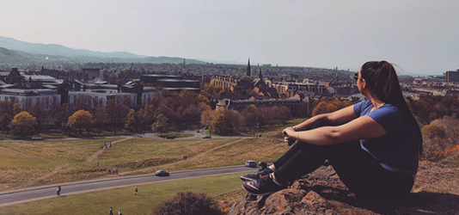

The experience itself was an extremely unique, interdisciplinary semester and encompassed so many good times.

Classes only make up half of the university experience; the rest is what you make of it. You can speed through university quickly and focus entirely on academics, but I have found that some of the best times I’ve ever had at SFU weren’t in a traditional classroom. I may be taking longer to get my degree, but studying abroad, working in Co-op jobs, and taking part in special academic semesters has been more than worth it.
First, I was able to study abroad in Dublin, Ireland, at University College Dublin for a semester, and it was possibly the best five months of my life. I took classes on Irish Folklore and Society, traveled all around Ireland with family and friends, and met some amazing people, all while immersed in a culture completely different than my own. It was definitely intimidating thinking of moving halfway across the world alone, and I had a couple of moments of pure panic and stress, having to figure everything out on my own, but it was the most fulfilling challenge I have ever faced and conquered, and I can’t wait to go back.
The following spring, I was able to take part in the Semester in Dialogue, a specialized, full-time, 5 day a week, 15 credit semester with a tight knit cohort of 16 students. In my semester, I learned ways that my fellow students and I could help improve society and exercise our sense of civic responsibility. We learned to break down issues like Homelessness, the Environment, Democracy, and Diverse Abilities into their many parts, and then tackle those issues on every level. I learned hosting and event planning skills, I was challenged to be creative and taught myself some graphic design, and I learned all about how to lead a dialogue and create a safe space for people to converse and learn from one another. I got to do all of this while getting to know some amazing fellow students. The experience itself was an extremely unique, interdisciplinary semester and encompassed so many good times.
I’ve had the pleasure of working in two different Co-op placements. In my second year, I secured a position as a Filming Intern at the Downtown Surrey Business Improvement Association, where I was able to work with seven other SFU co-op students. In my time there, I filmed and edited tons of videos, attended and helped run several events, and had entirely too much fun. Next, I worked for SFU itself, in the Arts and Communication Co-op departments, as a Special Projects Assistant. Within the first term, I learned so much more about graphic and other content design and production, canvas course design, copy-editing, blogging, marketing, event hosting, presentation design, and so much more. Taking part in these Co-op semesters has made me so much more confident that I can tackle the professional world when I graduate. I have gained invaluable experiences, skills, and connections that I never would have had if I didn’t apply to Co-op.
On top of all of the opportunities I’ve already mentioned, there are countless others like student clubs, positions in student government, volunteer and work positions on campus where you can help other students, and so much more. I honestly think no matter who you are, you could find an opportunity at SFU that you would love. I think if you make the most of your time at SFU, you will find immeasurable value in your degree, and you just might have the time of your life.

